**Practical 1**

**Aim:** Write a program to implement MongoDB data models.

**Q1.** Create a database named as empdb with collection name emp.

1. **Embedded data model:**

**Code:**

use empdb

db.createCollection("emp")

db.emp.insert({

name: "Aniket",

age: 20,

email: "aniket2004@gmail.com",

detail: [{contact:1234567890, familyMember: "five"},{contact:0987456123,familyMember:"Three"}]

})

**Output:**

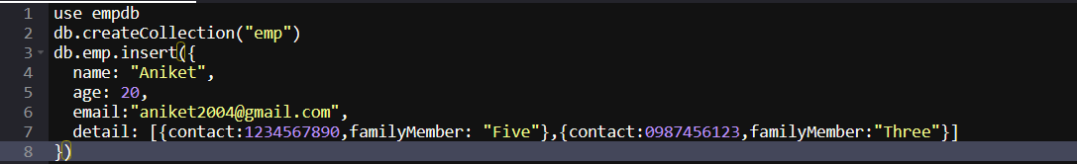

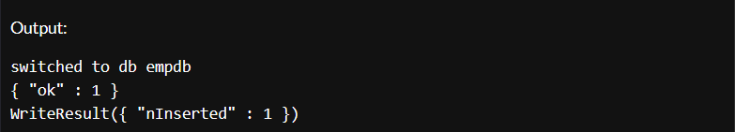

1. **Normalized data model:**

**Code:**

db.emp.insert({

name: "Aniket",

age: 20,

website: "empCompany.com"

})

db.emp.find()

**Output:**

